Comp Sci 1

VISUAL BASIC

“Math Aid”

Worth 75 points

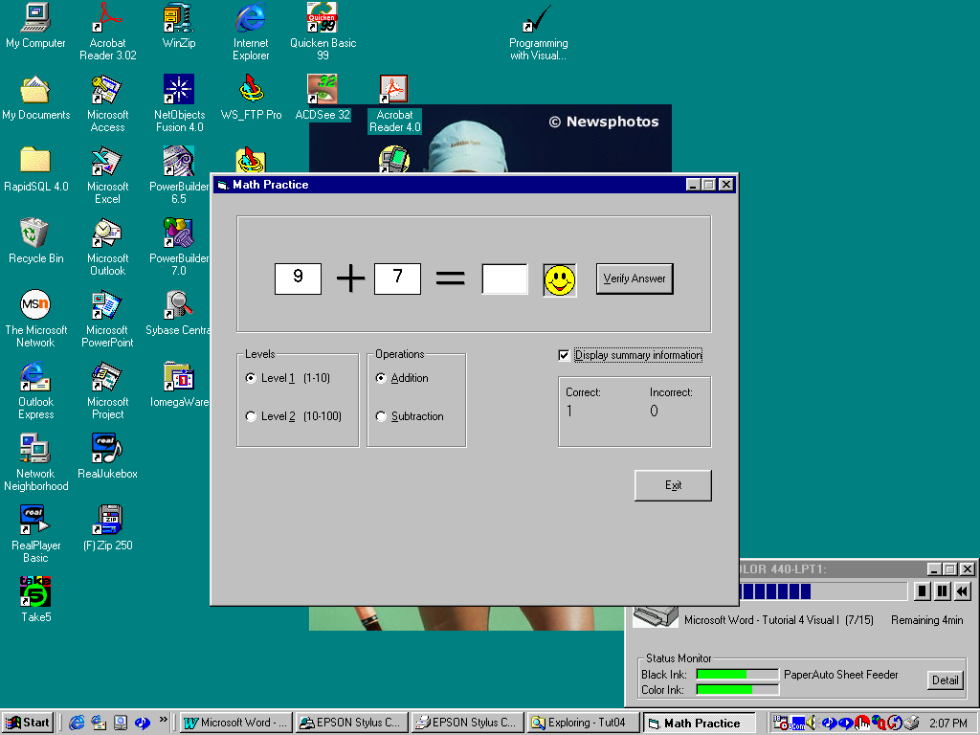

Objective: Create a project that helps first and second graders to learn simple math operations
such as addition and subtraction.

Project Description:

The program will, at a minimum, allow users to test their skills ad simple addition and subtraction. If you complete the program as detailed the maximum points you can get is 60 (out of 75). To get the max points, you will need to enhance the program to handle multiplication and division and to add another level of complexity.

The program should work as follows:

Allow the user to select a level of difficulty (the “levels” option buttons). Default to level 1

Allow the user to select from several operations (add, subtract, mult or divide). Default to add

Use the random number generator to display an initial problem by valuing the 2 text boxes.

The user will type in an answer and hit the verify button.

Once the button is clicked, evaluate the answer and display a happy face if correct or a sad face and a message box to “try again” if wrong.

Record (using static or form level vars) the number of correct and the number of wrong answers.

Once the correct answer is given, supply a new problem.

Allow the user to quit the program and make sure they know what input is required.

